# CS 255 System Design Document

## UML Diagrams

### UML Use Case Diagram

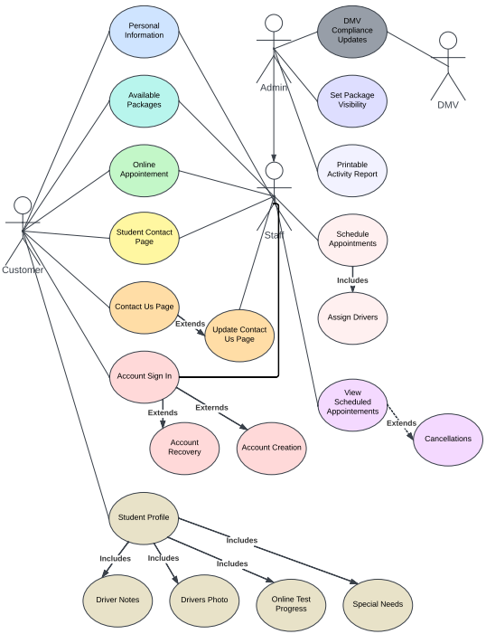

### UML Activity Diagrams

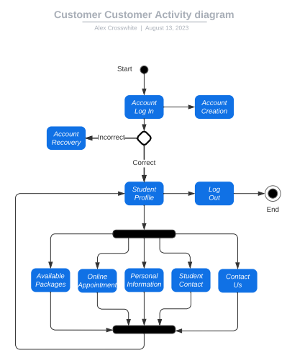

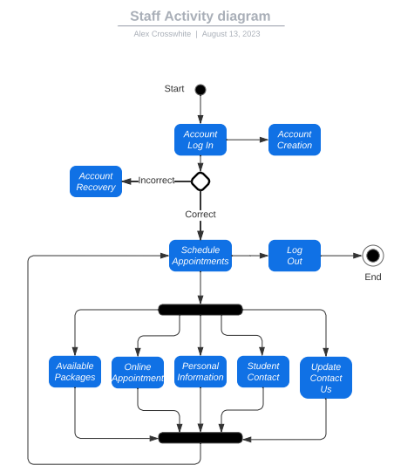

### UML Sequence Diagram

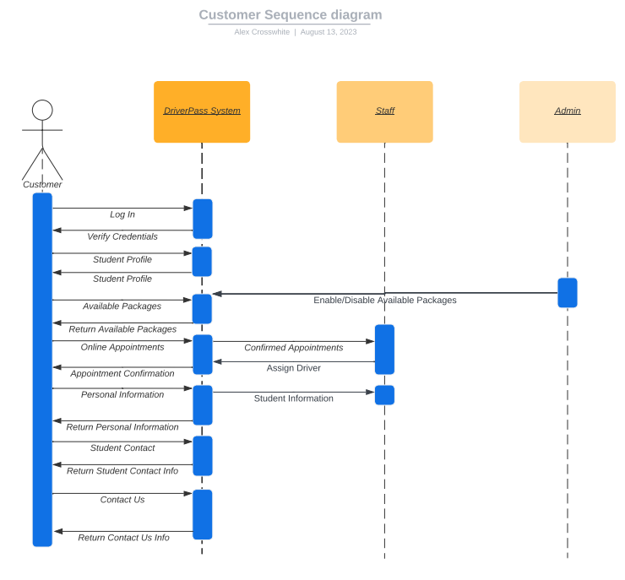

### UML Class Diagram

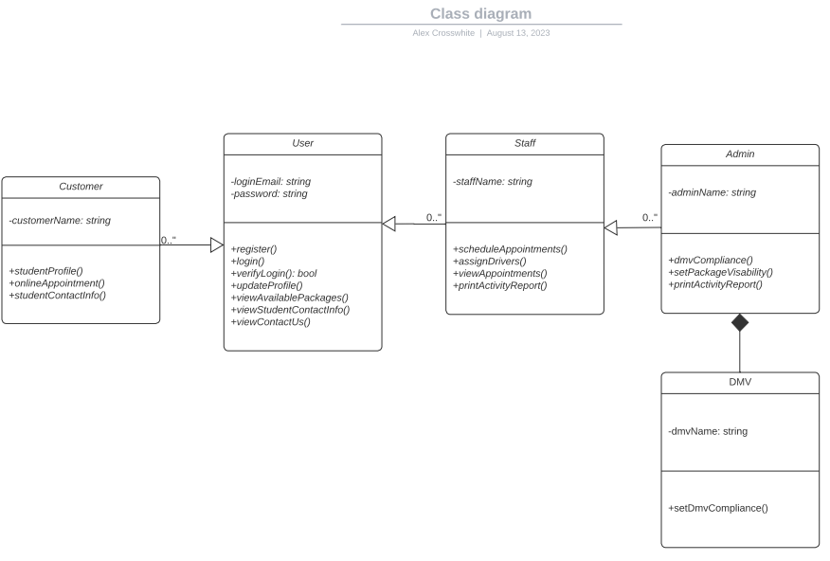

## Technical Requirements

This system addresses the need for authentication and authorization through a secure user verification process and account recovery option. Data encryption serves to offer information security as user data travels to and from the clients and servers. Data quality is ensured through the use of consistently updated compliance standards.

Internal controls are in place, only allowing the highest level of access to admin users. This system makes use of interoperability, allowing access to the system through various internet capable devices. The system is designed with performance in mind, allowing many users to access the system at one time without noticeable negative impact.

Observing these technical requirements creates a strongly structured system that provides users with the greatest amount of security, operability, and reliability. This creates a useful environment that ensures users of the system are able to get the most benefit DriverPass has to offer.